# UNIT 2

**Computer Architecture**

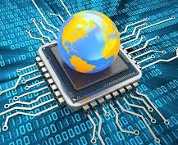

Picture 2.1

**Learning Outcomes**: By the end of the lesson, the students are expected to be able to use appropriate English to:

* identify and describe kinds of computer
* read a computer advertisement
* identify parts of computer
* describe functions of parts of computer
* identify comparatives and superlatives
* identify phrases used for presentation
* perform a presentation using phrases explained
* compare and contrast computers and any other devices using comparative and superlatives

# Reading a computer advertisement

**Exercise 1:** You are going to listen to an extract from an ICT class about **five** types of computer.

As you listen, identify the pictures (a-e) with words from the box.

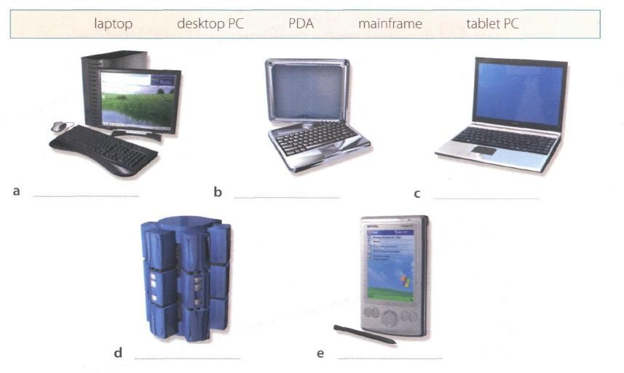

Picture 2.2

**Exercise 2**: Listen again and decide whether these sentences are true or false. Correct the false ones.

* + 1. A mainframe computer is less powerful than a PC. (T/F)
    2. A mainframe is used by large organizations that need to process enormous amounts of data. (T/F)
    3. The most suitable computers for home use are desktop PC. (T/F)
    4. A laptop is not portable. (T/F)
    5. Laptops are not as powerful as desktop PCs. (T/F)
    6. Using a stylus, you can write directly onto the screen of a tablet PC. (T/F)
    7. A Personal Digital Assistant is small enough to fit into the palm of your hand. (T/F)
    8. A PDA does not allow you to surf the Web. (T/F)

**Exercise 3**: Match these names to the different types of computer.

tablet

laptop

supercomputer

microcomputer

PC

minicomputer

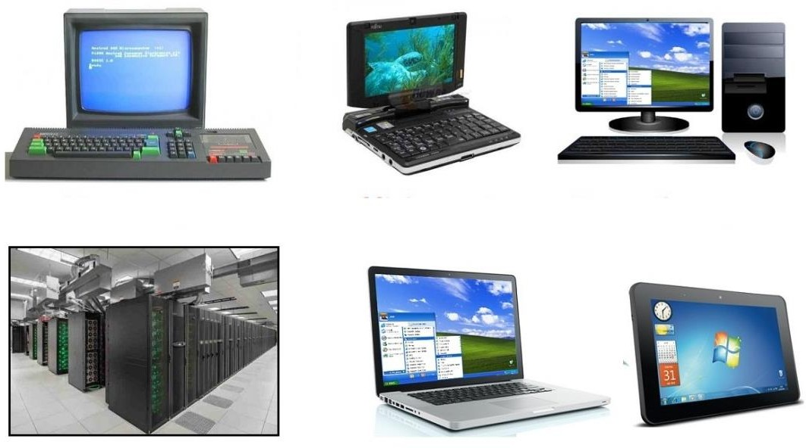

Picture 2.3

|  |  |  |
| --- | --- | --- |
| 1. minicomputer | 3. tablet | 5. PC |
| 2. laptop | 4. microcomputer | 6. supercomputer/mainframe |

**Exercise 4**: Listen to Part 1 of the conversation between a shop assistant and a customer. Tick

(√) the correct answers to the questions below.

1. The customer wants a computer for......
   * writing □ internet □ games
   * graphics □ video
2. A multimedia computer provides......
   * sound □ telephone
   * graphics □ video
   * games

**Exercise 5:** Listen to Part 2 of the conversation. In column A, tick hardware items named. In

column B, tick the items the assistant recommends.

|  |  |  |  |  |  |
| --- | --- | --- | --- | --- | --- |
| **A** | **B** | **Device** | **A** | **B** | **Device** |
| □ | □ | multimedia computer | □ | □ | handheld |
| □ | □ | multimedia notebook | □ | □ | printer |
| □ | □ | subnotebook | □ | □ | monitor |
| □ | □ | laptop | □ | □ | Modem |

**Exercise 6**: Study the text entitled ”How to Read a Computer Ad” and then answer the following

questions.

1. What is the memory size of PC? 16 GB dual channel DDR4 SDRAM
2. What storage devices are supplied? 512 SSD & 2 TB Serial ATA hard drive (7200 r.p.m)
3. What size is the display screen? 42” TFT flat panel 4K (3840 x 2160) monitor
4. How fast is the processor? Base Clock: 3.6 GHz, Bus Speed: 800 MHz
5. What is the capacity of the hard drive? 2 TB Serial ATA hard drive (7200 r.p.m)
6. Which operating system does it use? Microsoft Windows 10 Professional
7. What multimedia features does the computer have?

* 8 GB GDDR6 NVIDIA PCI-Express video graphic card
* Integrated Dolby Atmos Stereo audio

**HOW TO READ A COMPUTER AD.**

|  |  |
| --- | --- |
| 1. Intel Core i7-9700K 9th Generation (Coffee lake). Base Clock: 3.6 GHz, Bus Speed: 800 MHz 2. Mini-tower chassis 3. 16 GB dual channel DDR4 SDRAM 4. 512 SSD & 2 TB Serial ATA hard drive (7200 r.p.m) 5. 8 GB GDDR6 NVIDIA PCI-Express video graphic card 6. Integrated Dolby Atmos Stereo audio 7. Corsair K95 RGB Platinum Keyboard 8. 42” TFT flat panel 4K (3840 x 2160) monitor 9. Microsoft Windows 10 Professional | TowerPC  Picture 2.4 |

|  |  |  |
| --- | --- | --- |
| 1. The main processing chip called a ‘core i7’ that was designed and manufactured by the intel Corporation. It operates at a clock speed of three- point six gigahertz and has a front-side bus that operates at a speed of eight hundred megahertz. 2. A small, tall and narrow style of case containing the computer system. 3. Synchronous dynamic random-access memory with a capacity of sixteen gigabyte. It is a high bandwidth, double data rate memory. | 1. A Solid-state drive with a 512 gigabytes storage and a hard drive with a capacity of two terabytes that uses a type of connection interface known as Serial ATA. It has a serial data connection rather than the original parallel connection. It rotates at a speed of seven thousand, two hundred revolutions per minute. 2. Electronics for driving the graphics output that has a memory capacity of eight gigabytes and uses a type of connection interface known as PCI-Express. | 1. Electronics for controlling the sound output that is built into the main electronics of the computer. 2. The K95 Platinum is a big keyboard. Dedicated media controls and a USB pass-through, a metal volume wheel, RGB lighting. It even comes with an extra set of textured keycaps for the WASD keys. 3. A forty-two inch, flat display screen made from thin film transistors with a resolution of 3840 by 2160. 4. The operating system that is used to control the   system. |

*Oxford English for Information Technology (2011: 11)*

# Describing functions of computer

We can describe the function of an item in a number of ways. Study these examples.

|  |  |
| --- | --- |
| **Using the present simple**   1. ROM *holds* instruction which are needed to start up the computer.   ***Used to-*infinitive, *Used for + -ing***  **form**   1. ROM is *used* to *hold* instructions which are needed to start up the computer. | 1. ROM is *used for holding* instructions which are needed to start up the computer.   **Emphasizing the function**   1. *The function of ROM is* to hold instruction which are needed to start up the computer. |

**Exercise 7**: Match each item with its functions. Then describe the functions in three ways as the

examples on the table above.

|  |  |
| --- | --- |
| **Items** | **Functions** |
| 1. RAM (G) 2. Processor (J) 3. mouse (A) 4. clock (I) 5. flash memory key (E) 6. monitor (C) 7. keyboard (B) 8. cache (H) 9. DVD-ROM drive (D) 10. ROM (F) | 1. controls the cursor 2. inputs data through keys like a typewriter 3. displays the output from a computer on a screen 4. reads DVD-ROMs 5. reads and writes to electronic chips on a card 6. holds instructions which are needed to start up the computer 7. holds data read or written to it by the processor 8. provides extremely fast access for sections of a program and its data 9. controls the timing of signals in the computer 10. controls all the operations in a   computer |

**DESCRIBE THE FUNCTION IN THREE WAYS**

1. RAM (Random Access Memory):
   * Function 1: RAM is a type of computer memory that stores data and programs that are actively being used by the computer's processor. It allows for quick access to this data, ensuring that applications run smoothly and efficiently.
   * Function 2: It serves as a temporary workspace for the CPU, where it can read, write, and manipulate data rapidly. This temporary storage enables multitasking and ensures that the computer can respond to user inputs promptly.
   * Function 3: RAM is a volatile memory, meaning it loses its data when the computer is powered off or restarted. This characteristic makes it suitable for tasks requiring fast data access but not for long-term data storage.
2. Processor (CPU - Central Processing Unit):
   * Function 1: The processor is the heart of a computer, responsible for executing instructions and performing calculations. It processes data, controls hardware, and manages the overall operation of the computer.
   * Function 2: It interprets and executes instructions from software programs, enabling tasks such as running applications, handling mathematical computations, and managing data flow within the computer.
   * Function 3: The processor's performance is crucial for determining the speed and efficiency of a computer system. Faster processors can execute tasks more quickly and handle more complex operations.
3. Mouse:
   * Function 1: A mouse is an input device used to control the movement of a cursor on a computer screen. It typically features buttons for clicking and a scroll wheel for additional functionality.
   * Function 2: The mouse provides a user-friendly and precise means of interacting with the computer's graphical user interface. It allows users to select, click, drag, and interact with icons, files, and applications.
   * Function 3: The mouse's role as a pointing device enhances user productivity and navigation, making it an essential tool for tasks such as web browsing, document editing, graphic design, and gaming.
4. Clock:
   * Function 1: The clock in a computer is responsible for controlling the timing and synchronization of various operations within the system. It ensures that different components work together harmoniously.
   * Function 2: It generates a consistent and precise timing signal that regulates the execution of instructions, data transfer, and communication between hardware components.
   * Function 3: The clock's function is critical for maintaining the stability and reliability of a computer system, as it prevents issues like data corruption and hardware conflicts by coordinating actions in a synchronized manner.
5. Flash Memory Key (USB Flash Drive):
   * Function 1: A flash memory key, often known as a USB flash drive, is a portable storage device used for storing and transporting data. It utilizes flash memory technology to store data reliably.
   * Function 2: It serves as a convenient and portable data storage solution, allowing users to transfer files between computers, backup important data, and carry documents, photos, and videos with ease.
   * Function 3: Flash memory keys are non-volatile, meaning they retain data even when disconnected from a power source. This characteristic makes them suitable for long-term data storage and backup purposes.
6. Monitor:
   * Function 1: A monitor is an output device that displays the visual output from a computer, including text, images, videos, and graphical user interfaces.
   * Function 2: It provides a visual interface for users to interact with the computer and view the results of their actions, making it an essential component for tasks such as web browsing, video editing, gaming, and more.
   * Function 3: Monitors come in various sizes, resolutions, and types (e.g., LCD, LED, OLED), allowing users to choose a display that meets their specific needs for clarity, color accuracy, and screen real estate.
7. Keyboard:
   * Function 1: A keyboard is an input device that allows users to input text, numbers, and commands into a computer by pressing keys. Each key represents a specific character or function.
   * Function 2: It serves as a primary means of text and data input for a computer, facilitating tasks such as typing documents, sending emails, and entering commands in software applications.
   * Function 3: Keyboards vary in design, with some including additional function keys, multimedia controls, and ergonomic features to enhance user productivity and comfort during prolonged use.
8. Cache (CPU Cache):
   * Function 1: Cache is a high-speed, small-capacity memory located close to the CPU. It stores frequently used data and instructions to provide rapid access and reduce the time the CPU spends waiting for data from slower memory sources.
   * Function 2: It enhances the overall performance of a computer by reducing memory latency and speeding up the execution of frequently accessed instructions and data, thereby improving the CPU's efficiency.
   * Function 3: Cache memory operates at speeds much closer to the CPU's processing speed than main memory (RAM), making it an essential component for optimizing computational tasks, including gaming and multimedia applications.
9. DVD-ROM Drive:
   * Function 1: A DVD-ROM drive is a hardware component that reads data from DVD-ROM discs. It provides access to various types of digital content stored on DVDs, such as movies, software, and games.
   * Function 2: It allows users to install software, watch movies, and access data stored on DVDs by reading the disc's data and transferring it to the computer's storage or memory.
   * Function 3: DVD-ROM drives are particularly useful for content distribution and data retrieval from optical media, although they have become less common with the rise of digital downloads and streaming services.
10. ROM (Read-Only Memory):
    * Function 1: ROM is a type of non-volatile memory that holds firmware or software instructions that are permanently written during manufacturing. These instructions are essential for booting up the computer and initializing hardware.
    * Function 2: It contains a set of instructions that are read-only and cannot be modified or erased by users. These instructions are crucial for the initial startup of the computer system.
    * Function 3: ROM provides the foundational software necessary to initialize the computer's hardware components, ensuring that the system can begin the boot process and load the operating system from other storage devices like hard drives or SSDs.

**Exercise 8**: With your partner, describe the functions of these items using the forms you have

learned before.

* + 1. Scanner

When you place a picture, document, or even an object on it and press a button, the scanner takes a super-detailed picture of whatever you put on it. Then, it sends that picture to your computer so you can see it or save it as a digital file. So, a scanner turns real things into computer pictures that you can look at or work with on your computer.

* + 1. Printer

A printer is like a machine that can draw pictures and words on paper just like a coloring book. When you send something from your computer to the printer, it uses special ink or toner to make a copy of what's on your screen and put it on a piece of paper. So, a printer helps your computer show its pictures and words in the real world on paper.

* + 1. CPU

The CPU (Central Processing Unit) is like the brain of your computer. It's super fast and really good at solving problems. When you do something on your computer, like playing a game or writing a document, the CPU is the one that does all the hard work. It takes your instructions and does the math and thinking to make things happen on your computer screen. So, the CPU is like the smart, fast thinker inside your computer that makes everything work.

* + 1. SSD

Is like a big library where you keep all your books and information. Traditional hard drives (HDDs) are like bookshelves with physical books. When you want to read a book, you need to walk to the bookshelf, find the book, and open it.

* + 1. hard disk driver

Think of a hard disk drive (HDD) as a special kind of library where you store your books, but it works more like a traditional library with physical books on shelves. Each book represents a piece of information or data on your computer.

* + 1. Ports

ports on a computer are like doors that help information and data go in and out for different purposes, like sending messages or connecting devices.

* + 1. mainframe computer

Similarly, a mainframe computer is a big, powerful computer that manages and controls a lot of tasks for a large organization or business. It keeps track of information, helps with calculations, and ensures everything operates efficiently, just like the boss in the factory control room.

* + 1. Barcodes

It's like a secret language that computers can understand. Barcode contain line dan numbers which can be scanned using a special machine.

* + 1. swipe cards

swipe cards are like keys that use information to unlock things or give you access to places. They make it easy and secure for people to get into buildings or use certain equipment.

* + 1. main memory

main memory is a fast workspace where your computer temporarily stores the information it's actively using, making everything run smoothly and quickly while you're using your computer.

# Comparing and contrasting computer

**Exercise 9:** Study these details of different types of computer. Find answers to the questions.

Which computer is?

* + 1. The most common? Microcomputer or personal computer
    2. Small enough for a pocket? Subnotebook
    3. The most common portable? Notebook
    4. Used by many people at the same time? Main frames
    5. Used like mainframes? Mini computer
    6. Also called a handheld computer? Handheld or palmtop
    7. The most powerful? supercomputers
    8. Not suitable for a lot typing? Handheld or palmtop

|  |  |
| --- | --- |
| **Types of Computer** | **Notes** |
| **Mainframes** | Large, powerful, expensive.  Multi-user systems – used by many people at the same time.  Used for processing very large amounts of data. The most powerful mainframes are called  *supercomputers.* |
| **Minicomputers** | Used like mainframes.  Not as big, powerful, or expensive as mainframes. Less common now because microcomputers have improved. |
| **Microcomputers or Personal**  **computers (PCs)** | The most common type of computer.  Smaller, cheaper, and less powerful than mainframes and minicomputers. |

|  |  |
| --- | --- |
| **Types of Portable** | **Notes** |
| **Laptop** | About the size of small typewriter.  Less common now because smaller and lighter portables are available. |
| **Notebook** | About the size of a piece of writing paper.  The most common type of portable. |
| **Subnotebook** | Not quite as big as notebooks. Can fit into a jacket pocket. |
| **Handheld or Palmtop** | Small enough to fit into the palm of one hand. Not easy to type with because of their size.  Specialized handheld computer known as PDAs are used as  personal organizers. |

**Exercise 10:** Study this comparison of three types of computer.

|  |  |  |  |
| --- | --- | --- | --- |
|  | **Mainframes** | **Minicomputers** | **Microcomputers** |
| **Size** | **+++** | **++** | **+** |
| **Power** | **+++** | **++** | **+** |
| **Cost** | **+++** | **++** | **+** |

We compare things using adjectives in two ways.

1. We can compare one type of computer with another.

*Minicomputers are* ***bigger than*** *microcomputers. Mainframes are* ***more expensive than*** *microcomputers.* For negative comparisons, we can say:

*Microcomputers are* ***not as big as*** *minicomputers. Microcomputers are* ***not as powerful as*** *mainframes.*

1. We can compare mainframes to all other types of computer.

*Mainframes are* ***the biggest*** *computers. Mainframes are* ***the most powerful*** *computers. Mainframes are* ***the most expensive*** *computers.*

With short adjectives (big*, small, fast*), we add *–er* and *–est* (*faster, fastest*). With longer adjectives (*powerful, expensive*), we use *more/less* and the *most/ the least* before the adjectives (*more powerful, the most powerful)*.

Remember some exceptions:

*good – better – the best bad – worse – the worst*

**Exercise 11:** Choose the correct adjectives. Then fill in the gaps with the correct form of the

adjectives.

|  |  |
| --- | --- |
| ***light/heavy***  ***large/small***  ***common/good***  ***powerful/expensive***  ***fast/cheap***  ***powerful/expensive*** | Laptops are lighter than desktop computers, but  heavier than notebooks.  The mainframes is the largest type of computer. A minicomputer is less powerful smaller than a microcomputer.  Personal computer are cheapest than mainframes but mainframes are more powerful than personal computers at processing very large amounts of data.  Minicomputers are less powerful than mainframes but they are also less expensive  New computers are powerful and sometimes  More expensive than older machines.  Laptops are often faster than PCs but they are not as cheap |

**Exercise 12**: Put the words in brackets into the correct form.

There are different types of computer. The (*large*) **1** and (powerful)

largest

**2** are mainframe computers. Minicomputers are (small)

Most powerful

**3** than mainframes but are still very powerful. Microcomputers are small enough to sit on a desk. They are the (common) **4** type of computer. They are usually (powerful) **5** than microcomputers.

smaller

More powerful

Most common

smaller

Portable computers are (small) **6** than desktops. The (large)

largest

**7** portable is a laptop. (Small) **8** portables, about the size of a piece of writing paper, are called notebook computers. Subnotebooks are (small)

smallest

smaller

smaller

**9** than notebooks. You can hold the (small) **10**

computers in one hand. They are called handheld computers or palmtop computers.

**Exercise 13**: In pairs, discuss who or what you think is:

1. The most difficult game you’ve ever played. Resident evil 4
2. The most exciting film you’ve ever seen. The mentalist (2008)
3. The funniest program on TV. Ini talkshow
4. The most dangerous computer virus. Marburg virus
5. The best blogger or webmaster on the web. Mr Beast
6. The most popular web browser. Google chrome

**Exercise 14**: Preparation is essential for an effective presentation. Here are some phrases that

can help you delivering a better presentation.

# Useful Phrases for Presentation

When giving a presentation, certain keywords are used to signpost the different stages. It’s a good idea to memories them and practice them so that they come to your mind easily during a presentation.

|  |  |
| --- | --- |
| **Useful Phrases for Presentation** | |
| **Starting the presentation** | **Explaining the purpose** |
| * Good morning/good afternoon ladies and gentlemen. * The subject of my presentation today is … * What I’m going to talk about today is … | * The purpose of this presentation is … * My objective is to … * My main aim today is to … |
| **Stating the main points** | **Introducing the first point** |
| * The main points I will be talking about   today are firstly …, secondly …., next …., finally, we’re going to look at… | * Let’s start/begin with … * I’d like to start by …. |
| **Showing visuals** | **Moving on to the next point** |
| * I’d like to illustrate this by showing you … | * Now let’s move on to … |
| **Referring to an earlier point** | **Summarizing** |
| * Let me go back to what I said earlier about   … | * I’d like to recap the main points of my presentation. First I covered …, then we   talked about … and finally we looked at …   * I’d now like to sum up the main points, which were … |

|  |  |
| --- | --- |
| **Conclusion Inviting** | **Questions** |
| * I’m going to conclude by … saying that / inviting you to / quoting … * In conclusion, let me leave you with this   thought / invite you to … | * Finally, I’ll be happy to answer your   questions.   * Now I’d like to invite any questions you   might have.   * Do you have any questions? |

**Exercise 15**: Now put the following phrases in the correct groups. Add some more phrases that

you know.

* In conclusion, let me leave you with this thought / invite you to …
* Good morning/good afternoon ladies and gentlemen.
* The main points I will be talking about today are firstly …, secondly …., next …., finally, we’re going to look at…
* I’m going to conclude by … saying that / inviting you to / quoting …
* Now let’s move on to …
* My objective is to …
* Finally, I’ll be happy to answer your questions.
* Now I’d like to invite any questions you might have.
* What I’m going to talk about today is …
* The subject of my presentation today is …
* I’d like to illustrate this by showing you …
* I’d like to recap the main points of my presentation. First I covered …, then we talked about

… and finally we looked at …

|  |  |
| --- | --- |
| Useful Phrases for Presentation | |
| **Starting the presentation** | **Explaining the purpose** |
| Good morning \/good afternoon ladies and gentlement | The subject of my presentation is… |
| **Stating the main points** | **Introducing the first point** |
| What im going to talk about today is… | My objective is to… |
| **Showing visuals** | **Moving on to the next point** |
| Id like to illustrate this by showing you | Now lets move on to |
| **Referring to an earlier point** | **Summarizing** |
| The main point I will be talking about today are firstly, secondly | Id like to recap the main points of my presetation. First I covered…, then we talked about … and we finally looked at … |
| **Conclusion** | **Inviting Questions** |
| In conclusion, let me leave you with this though/invite you  Im going to conclude by … saying that/inviting you to | Finally, ill be happy to answer your questions.  Now id like to invite any questions you might have |

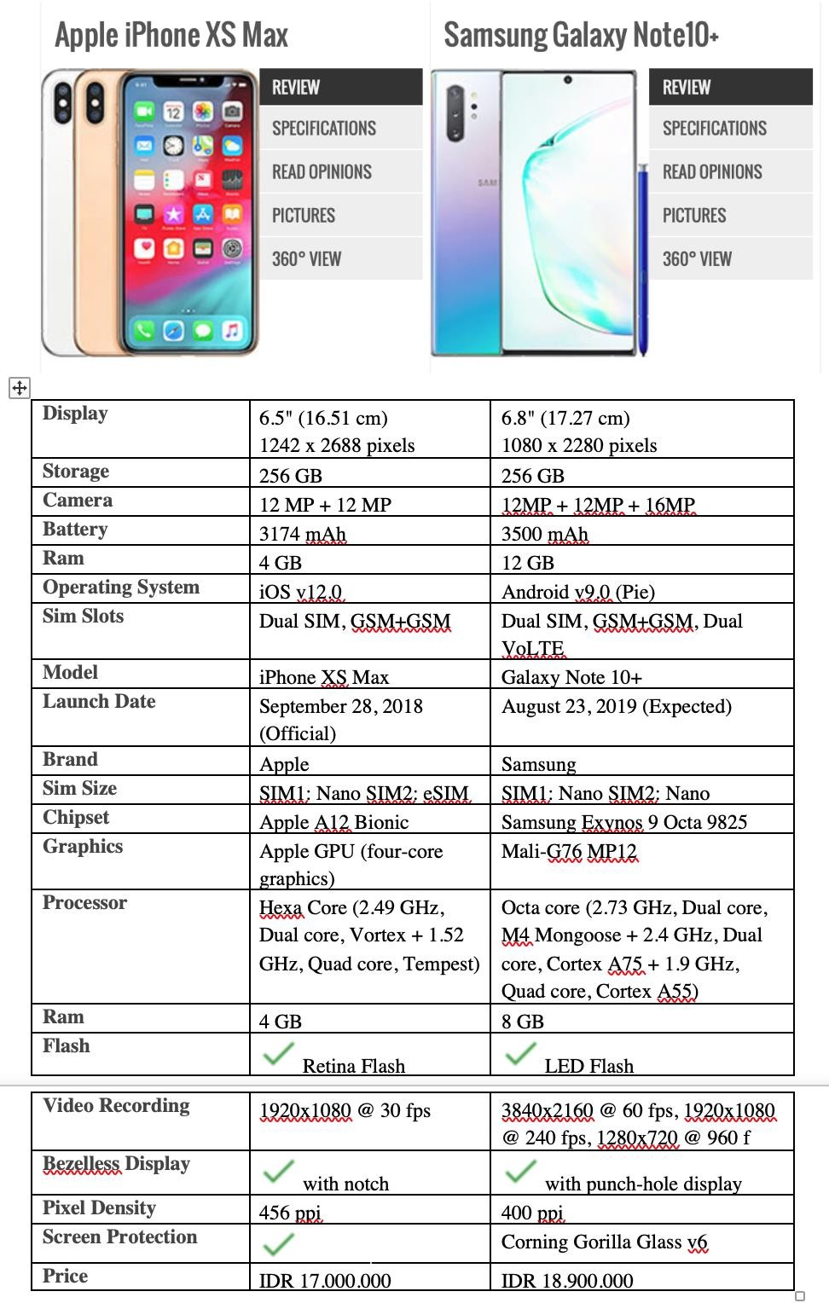

Picture 2.5

**Exercise 16**: In pairs, find two different advertisements of PCs/laptops/any gadgets and write some comparisons (at least 10 sentences) based on their specifications and present it in the class. Use the phrases that you have learned today.

# Look at the example below.

**Example of Writing a Comparison between Two Things**

1. Samsung Galaxy Note 10+’s size is bigger than iPhone XS Max’s.
2. The storage of Samsung Galaxy Note 10+ and iPhone XS Max has the same capacity.
3. The price of Samsung Galaxy Note 10+ is more expensive than iPhone XS Max.
4. The battery of Samsung Galaxy Note 10+ is more powerful than iPhone XS Max.
5. The apple brand is more popular than Samsung.
6. Samsung Galaxy Note 10+ RAM is bigger than iPhone XS Max
7. The Pixel density iPhone XS Max is bigger than Samsung Note 10+
8. The display of iPhone XS Max more colorful than Samsung Note 10+
9. The camera of iPhone XS Max has smaller mega pixel than Samsung Note 10+
10. The flash of Samsung Note 10+ is more powerful than iPhone XS Max.